Description DoCument

# Introduction and working

We were to make a Simple Notes Archive, a client/server based application that can record and retrieve notes stored by a user from a server.

The client takes as input, a username and text notes from the user and keeps them in memory. Periodically, the client will share this data with a server; archiving. The application also allows the user to access notes based on his username. The server, receives the notes and stores them in memory.

# How to run

Run server using CMD.   
Run client while the server is up and running.

# Profiler

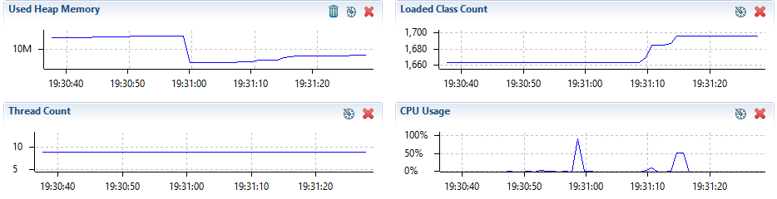

# Github link